Creating Accomplishment Statements

Accomplishment statements are important to go beyond just your job responsibilities. One way to do this is to think of the “5 W’s and an H”

WHO – Who did your job help? The company? Clients? Customers?
WHAT – What happened with the results of the job? If you did research, was that information published? If you had to do a report what was done with that information? Include what RESULTS, IMPACT or CONTRIBUTION your actions had.
WHEN – When did this happen? Daily? Weekly, Monthly? Talking about how often you did something is an easy way to show productivity in your job.
WHERE – Where did your duties occur? Did you have to travel for a job? Were you responsible for interacting with people outside of your organization?
WHY & HOW– Why did you do this? How did your job duties help the organizations ability to function?

TIPS:
- Use your performance reviews to help you get started.
- Create a list of the things you are most proud of accomplishing.
- Use numbers to quantify information (i.e., timeframe, money).
- If you get really stumped on how to write your accomplishment statement break it down to your basic responsibilities and use the ”Power Verbs for Your Resume” list below to get started.
Example – Job responsibilities that require using communication skills go to that section and pick the appropriate word to start your statement.
Here is an example of how to reframe your contributions to focus on impact. The context will set you apart from other candidates and exemplify your skills and expertise in terms of direct results.

BEFORE
XXX Inc., Any Town, OR June 2009-present
Sales Associate
- Assisted with inventory
- Provided quality customer service
- Built displays for featured products

AFTER
XXX Inc., Any Town, OR June 2009-present
Sales Associate
- Performed monthly inventory of over 1200 domestic and foreign products ensuring a perfect record of regulatory compliance in monthly audits over two continuous years.
- Provided quality customer service by handling customer questions, complaints, and problem solving to a positive resolution; achieved a 99% overall customer satisfaction rating for 2017.
- Increased divisional sales by 15% per quarter through ongoing hands-on support of marketing strategies including building displays for featured products.

Writing Effective Accomplishment Statements

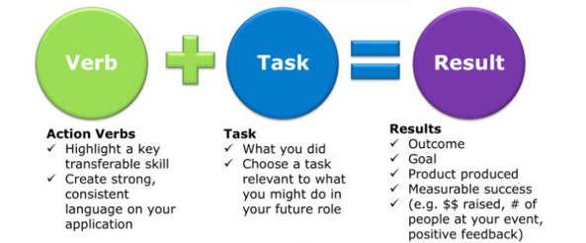

- Think of a time when you accomplished something beyond your usual job duties.
Try and highlight one strength/ skill you used to achieve it.
- Write it down highlighting 3 key areas:
  - Problem/Challenge: Under what circumstances or conditions did you do the work? Was there a tight deadline? Did you have to do it under stress or with no supervision? Did you have to take on an additional project while still maintaining your current workload?
  - Action: What did you do, and what skills / abilities did you use, to take care of the situation? Be specific here, and use strong action verbs. Use the list of strong action verbs from the list below
  - Result: What was the end result? Sometimes you can discover this by imagining what would have happened if the situation wasn’t handled as well as you did. Examples of results could be increased revenue / sales, increased customer satisfaction, projects completed successfully (or within/under schedule/budget), increased efficiency, etc.

- Turn the accomplishment into a short sentence for your resume, starting with the result first, and adding context and scale for more power.

Example
“Trained new employees.”
Can be turned into an accomplishment by adding the result of the actions taken…
“Trained new employees resulting in increased customer satisfaction.”
… and then made more impressive by adding numbers for context or time…
“Trained more than 15 new employees over a 12 month period resulting in increased customer satisfaction.”
… and made even more impressive by measuring the result and putting that result at the beginning of the entire statement:
“Increased customer satisfaction by 25% through effectively training 15+ new employees over 1 year.”
Writing your summary
- 4-6 lines long
- Highlights your unique value
- After writing the work history section of your resume and doing the branding activity
Begin your resume summary with:
- Who you are and what you do
  - A single descriptive adjective (optional)
  - Professional title
  - Key certification (if you have one)
  - Years of experience
- Achievements and skills
ASK
- What are my brightest moments?
- What am I proud of achieving?
- What do I love most about what I do?
- What do I do best?
g
- You may include
  - 1–2 achievements
  - 2–3 skills
  - Pick 3 that are not generic:
    - Pick the ones that make you stand out - Value proposition
    - Scan the job description. Highlight the skills and achievements you see.
    - Pick the best parts of your resume that match.
1
2
3

- Add measurements and proof
Why what you do is important
  - Focus on results
  - Add numbers and details

Put it together: Who you are + Skills+ quantified results

Examples

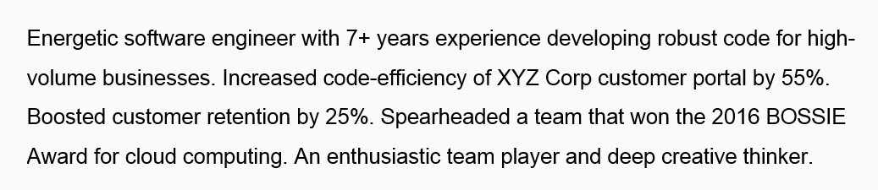

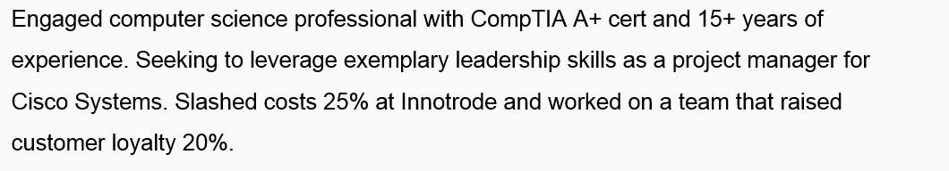

Power Verbs for Your Resume

Planning
Developed and implemented a training program that resulted in a 45% increase in employee satisfaction

Administered
Anticipated
Commissioned
Determined
Developed
Devised
Evaluated
Forecasted
Formulated
Identified
Observed
Planned
Prepared
Prioritized
Researched
Reserved
Revised
Strategized
Studied
Tailored

Organizing
Coordinated weekly office schedules for 8 employees

Acquired
Activated
Adjusted
Allocated
Altered
Appointed
Arranged
Assembled
Assessed
Assigned
Authorized
Cataloged
Centralized
Charted
Classified
Collected
Committed
Confirmed
Contracted
Coordinated
Customized
Delegated
Designated
Designed
Dispatched
Established
Facilitated
Housed
Implemented
Incorporated
Instituted
Issued
Linked
Logged
Mapped out
Neatened
Obtained
Ordered
Organized
Procured
Programmed
Recruited
Rectified
Retrieved
Routed
Scheduled
Secured
Selected
Simplified
Sought
Straightened
Suggested
Tracked
Tracked

Executing
Handled 20-35+ customer calls per shift regarding coverage changes, renewal rates and billing procedures

Acted
Administered
Carried out
Collected
Completed
Conducted
Displayed
Distributed
Entered
Exercised
Forwarded
Handled
Input
Installed
Labored
Merchandised
Operated
Performed
Processed
Produced
Proofed
Prospected
Proved
Shipped
Sold
Stocked
Transacted

Supervising
Supervised the implementation of new computer filing system that reduced paper use by 35%

Adjusted
Analyzed
Apportioned
Assessed
Certified
Compared
Controlled
Corrected
Correlated
Developed
Discovered
Established
Examined
Explored
Graded
Indexed
Inspected
Judged
Licensed
Maintained
Measured
Modified
Monitored
Officiated
Overhauled
Oversaw
Policed
Prohibited
Refined
Regulated
Reviewed
Revised
Screened
Scrutinized
Set
Supervised
Supplied
Tightened
Traced
Updated

Getting Results
Increased student participation by 25% over a 6-month period

Accomplished
Achieved
Added
Advanced
Attained
Augmented
Boosted
Built
Combined
Completed
Consolidated
Constructed
Contributed
Delivered
Demonstrated
Diminished
Earned
Eclipsed
Eliminated
Enjoyed
Enlarged
Enlisted
Ensured
Excelled
Expanded
Expedited
Extended
Finalized
Fulfilled
Gained
Generated
Grew
Guaranteed
Hastened
Heightened
Improved
Increased
Innovated
Integrated
Introduced
Invented
Joined
Launched
Lightened
Minimized
Modernized
Obtained
Opened
Orchestrated
Overcame
Prevailed
Produced
Qualified
Realized
Received
Reduced (losses)
Rejuvenated
Renovated
Restored
Targeted
Uncovered

Leading
Trained 20+ new employees in computer procedures over a 2-year period

Accelerated
Assumed
Caused
Chaired
Changed
Conducted
Directed
Disproved
Elected
Employed
Empowered
Encouraged
Enlisted
Envisioned
Fostered
Founded
Guided
Hired
Influenced
Initiated
Inspired
Involved
Led
Managed
Mentored
Motivated
Originated
Pioneered
Promoted
Raised
Recognized for
Set goals
Spearheaded
Stimulated
Strengthened
Supervised
Trained
Transformed
Visualized

Problem Solving
Streamlined ordering through the use of computer technology, decreasing wait time from 6 to 2 days

Alleviated
Analyzed
Applied
Brainstormed
Collaborated
Conceived
Conceptualized
Crafted
Created
Debugged
Decided
Deciphered
Detected
Determined
Diagnosed
Engineered
Foresaw
Formulated
Found
Gathered
Investigated
Recommended
Remedied
Remodeled
Repaired
Resolved
Revamped
Revitalized
Revived
Satisfied
Solved
Streamlined
Synthesized
Theorized

Quantitative
Converted files from COBAL to JAVA in order to increase compatibility with current systems

Accounted for
Appraised
Approximated
Audited
Balanced
Budgeted
Calculated
Checked
Compiled
Compounded
Computed
Conserved
Converted
Counted
Dispensed
Dispersed
Earned
Enumerated
Estimated
Figured
Financed
Grossed
Increased
Inventoried
Maximized
Multiplied
Netted
Profited
Projected
Purchased
Quantified
Rated
Reconciled
Recorded
Reduced
Tabulated
Totaled

Communicating
Presented to groups of 30+ transfer students on a weekly basis concerning university procedures

Acted
Adapted
Addressed
Admitted
Allowed
Amended
Arbitrated
Argued
Ascertained
Attested
Briefed
Clarified
Cleared up
Closed
Communicated
Composed
Concluded
Consented
Consulted
Convinced
Corresponded
Critiqued
Dedicated
Defined
Deliberated
Demonstrated
Drafted
Dramatized
Edited
Educated
Elicited
Explained
Extracted
Fabricated
Fashioned
Greeted
Highlighted
Illustrated
Improvised
Indicated
Inferred
Informed
Instructed
Interpreted
Interviewed
Justified
Lectured
Marketed
Mediated
Moderated
Negotiated
Perceived
Persuaded
Presented
Publicized
Queried
Questioned
Referred
Reinforced
Related
Rendered
Reported
Represented
Revealed
Sanctioned
Settled
Shaped
Smoothed
Sold
Solicited
Specified
Spoke
Submitted
Substantiated
Suggested
Summarized
Supplemented
Supported
Surveyed
Synthesized
Systematized
Taught
Tested
Translated
Transmitted
Verified
Welcomed
Wrote

Helping
Provided academic support for 30+ primary students through comprehensive after-school program

Accommodated
Advised
Aided
Alleviated
Assisted
Assured
Bolstered
Coached
Continued
Cooperated
Counseled
Dealt
Eased
Elevated
Enabled
Endorsed
Enhanced
Enriched
Familiarized
Interceded
Mobilized
Modeled
Polished
Prescribed
Protected
Provided
Rehabilitated
Relieved
Rescued
Returned
Saved
Served
Sustained
Tutored
Validated

